# **MIAQuant_Learn: User manual**

## MIAQuant_Learn Folder description

This folder contains:

* two main source files that are:
  + *“ClickSamples_TrainClassifiers.m”*: running this source file allows to collect the training data (by manually clicking on pixels in sample sub-images); after sample collection the classifiers are trained.
  + *“MIAQuant_Learn.m”*: running this source file allows to eventually register sets of serial sections, segment the markers in each section, and then compute: 1) mean-distance histograms and their intersection; 2) co-existence measures.
* the folder “\private” containing all the source files.
* the folder “\TrainedClassifiers” where the trained classifiers are saved.

**Description of processing folder and Image name protocol**

The processing folder must contain sets of (eventually serial) sections, each relative to one tissue sample.

The name of each image contains:

1) **sample code** **(reported in the first part of the image-name, delimited by “_”)**;

2) **marker name** **(reported in the second part of the image-name, delimited by “_”)**;

3) **color name** **(reported in the third part of the image-name, delimited by “_”)**:

IMPORTANT NOTE ABOUT THE COLOR NAME: the color name might be splitted into two parts separated by character “-”. The first part reports the specific color name (learnt by the analysis of sample (marker+not-marker+critical-not-marker) pixels clicked by users on sample sub-images extracted from the dataset, as explained in the paper). The second part reports the “basic color” name (learnt by the analysis of color pixels sampled by users by drawing polygons on color images). For a clearer explanation see below.

The images can be split into vertical blocks.

Precisely, if a section image is split into three blocks, the names of the three blocks are:

patCode_CD3_BMCR-R_**01**.tif,

patCode_CD3_BMCR-R_**02**.tif,

patCode_CD3_BMCR-R_**03**.tif

where the last two numbers in the names (“01”, “02”, “03”) identify the vertical block.

These examples show our strategy to deal with huge images, since Matlab memory storage limits do not allow to open images bigger than 1.5 Gb.

When the image of the tissue sample is to big, it is split into consecutive (from left to right) **vertical-block** **sub-images**. The information about the block is reported at the end of the image name, as described above.

This splitting system allows Matlab to separately open the vertical-block sub-images, compose the original region-sub-image, and process it.

IMPORTANT NOTE: when the images are small enough to be opened without problems, they MUST anyway be considered as the first/unique block-sub-image (01), and they MUST therefore be named with the ending “01” string: patCode_markerName_markerColor_01.tif

To end the image name description, the second part of the name, delimited by the underscore charater (“_”), reports the name of the marker (e.g. CD3, CD163, Ki67 …), while the third part reports the name of the staining color (in our examples the color is BMCR=reddish color, while the basic- color name is R). These names could be any name (e.g. pippo, pluto, brown, BMCR, …).

When only biomarker segmentation + marker co-existence estimation is needed (NO serial section registration and comparison) the processing folder must contain all the images of tissue samples (*.tif format) to be segmented. Be careful! Images must be named according to the image-name protocol described above.

When serial section registration is also needed, the processing folder must contain, **for each tissue sample to be quantified**, a set of images representing N serial sections (*.tif format) of that tissue sample, one section for each marker. Again, images must be named according to the image-name protocol described above.

The processing folder must contain a folder named **“\InfoImgs”**, containing color images with the same name and size of the images to be processed. Each image in this folder contains:

* manual landmark points (if manual landmark registration is required as in MIAQuant): they must be signed with dots colored with the green RGB color, that is [0,255,0].
* border of interest from which mean-distance histogram must be computed: they must be signed with the magenta RGB color, that is [255,255,0]. If distances must be computed from a point of interest, the user can draw a small dot.

IMPORTANT NOTICE: given a set of serial sections, a semantically similar set of manual landmarks should be placed in each section. The manual landmarks must be enough (at least 3), they must be placed in each image on “corresponding and meaningful” locations, the polygon they limit as vertexes should not be a regular shape (a square, equilateral triangle).

## Collecting Training Data and Training the classifiers

The training data consists of:

1) pixels selected from RGB images such as:

   

The pixels selected from such images are used as training pixels for a decision tree (DT) which discards pixels whose color is completely different from that of marker pixels. If the basic color is named “nameBasic”, the user-selected training pixels are saved in folder “\TrainedClassifier\DataBasicColor_nameBasic”.

2) marker-pixels, not-marker pixels, critical-not-marker pixels manually clicked from the images to be processed. IMPORTANT: since the images are usually characterized by an high pixel dimension, directly selecting training pixels from them is be too time consuming (Matlab takes more time to open images of high dimensions). For this reason, we recommend to select training pixels from image portions (sub-images) extracted from the images to be processed and saved in a separate folder. The sub-images portion must be named according to the name protocol and we suggest they are extracted in order to capture all the different marker color appearances, and all the deficits that must be faced. Selecting pixels from these sub-images allows to have a training set containing all the positive and negative examples that must be faced by the classifiers. In the following we will referred to the sub-image folder as sampleImage folder. If the color is named “nameColor”, the user-selected training pixels are saved in folder “\sampleImages\DataColor_nameColor”. Saving the training points is important to eventually update them by adding extra points.

To select training points, open “ClickSamples_TrainClassifiers.m” (saved in the MIAQuant_Learn folder) with the latest Matlab release (see image below).

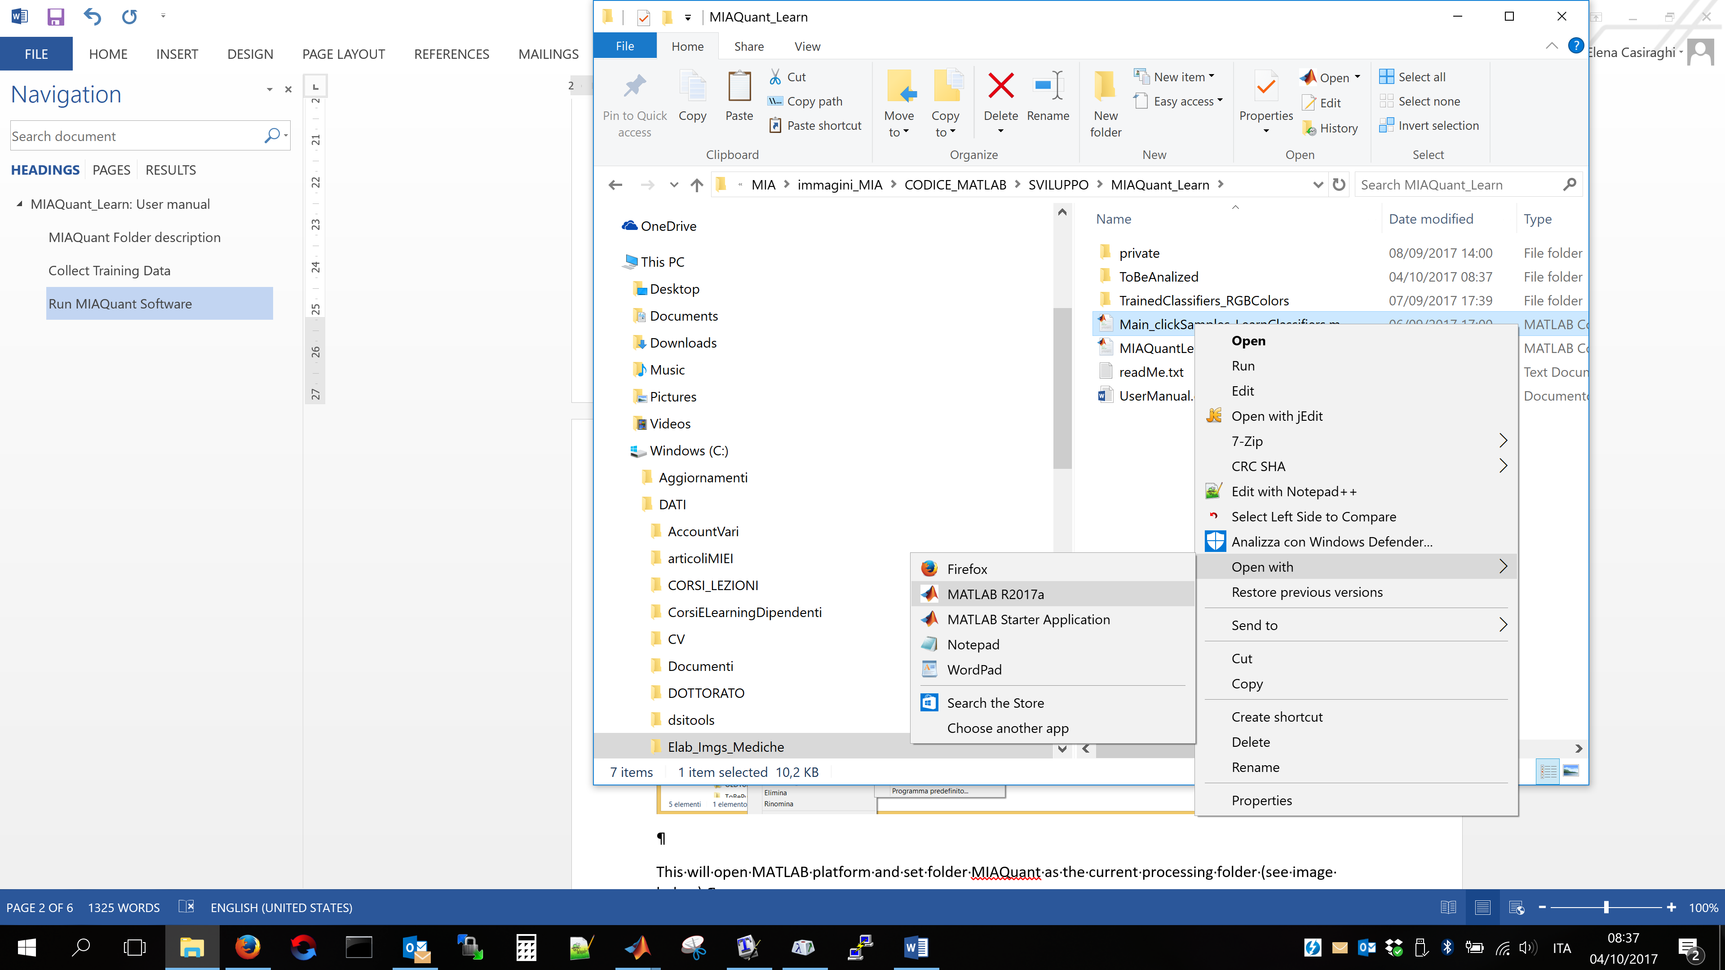

This will open MATLAB platform and set folder MIAQuant_Learn as the current processing folder (see image below).

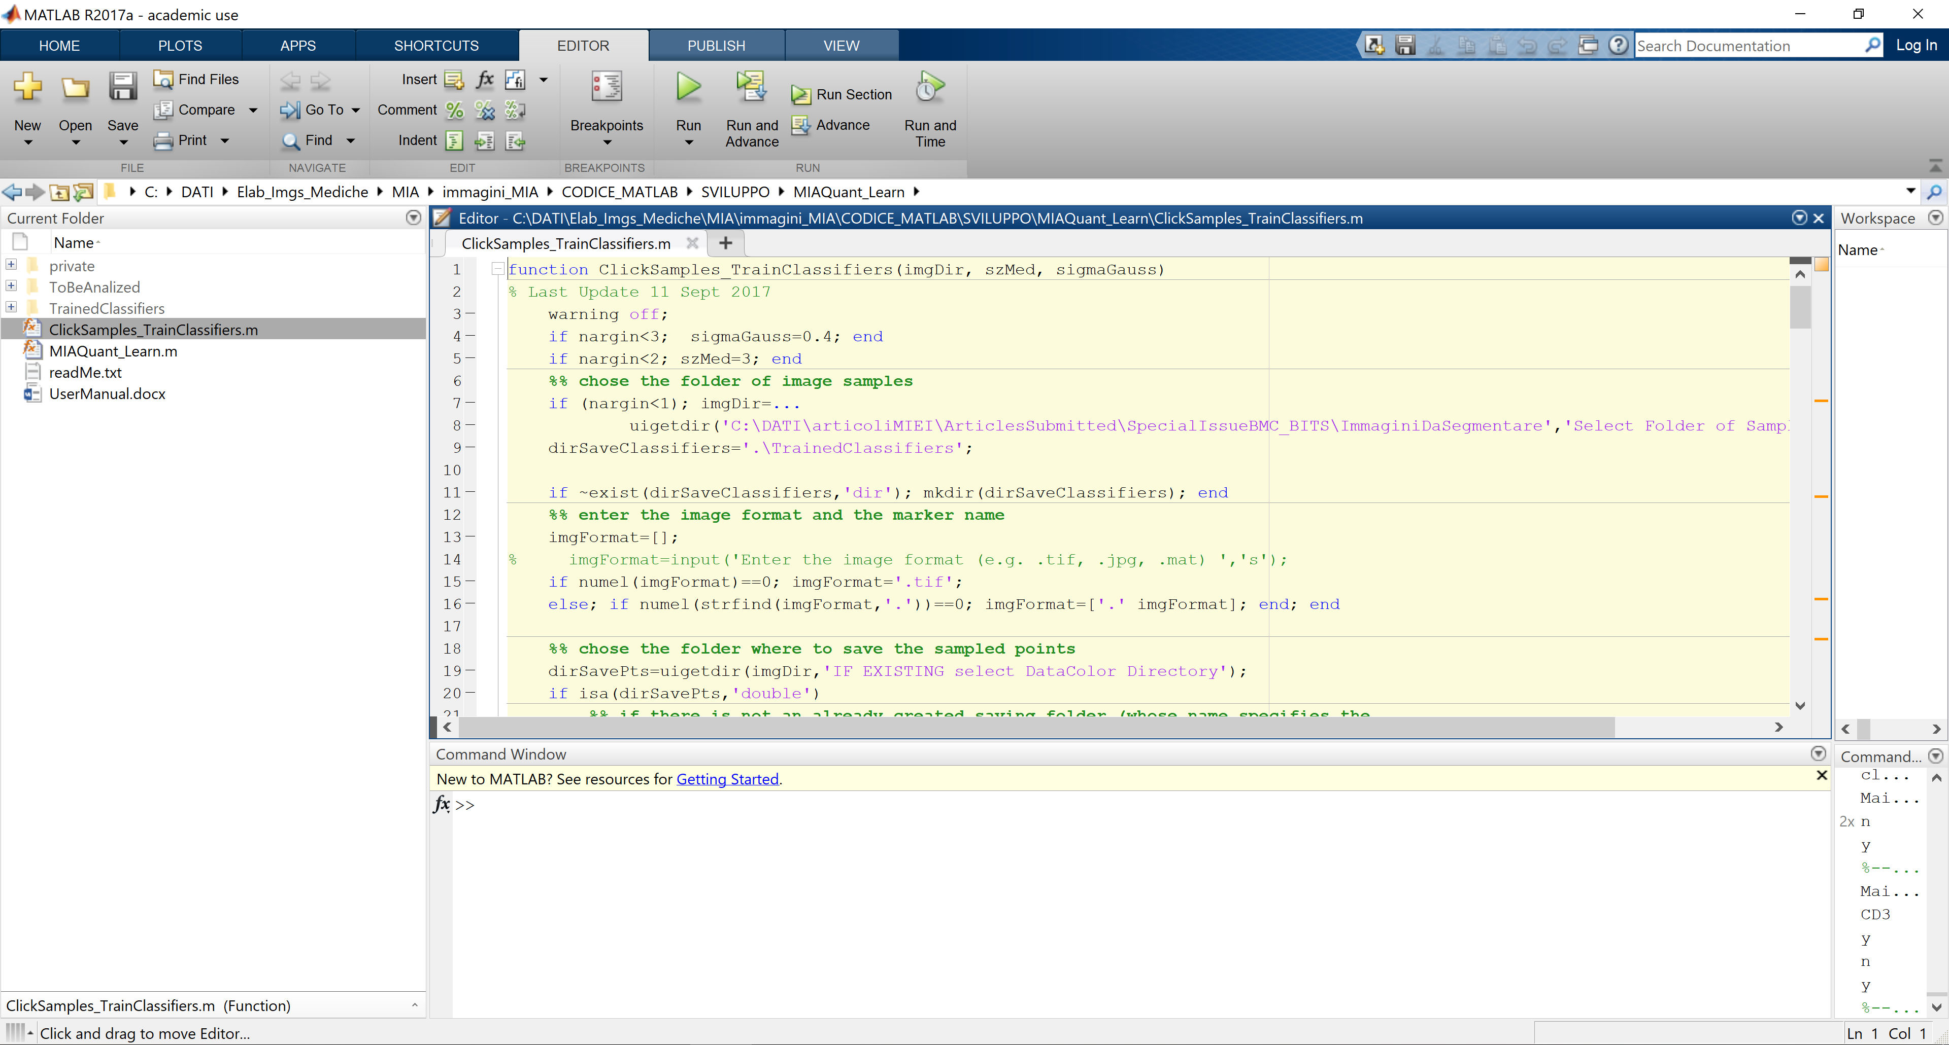

To run the code, in the command window write “ClickSamples_TrainClassifiers” and press ENTER (see image below)

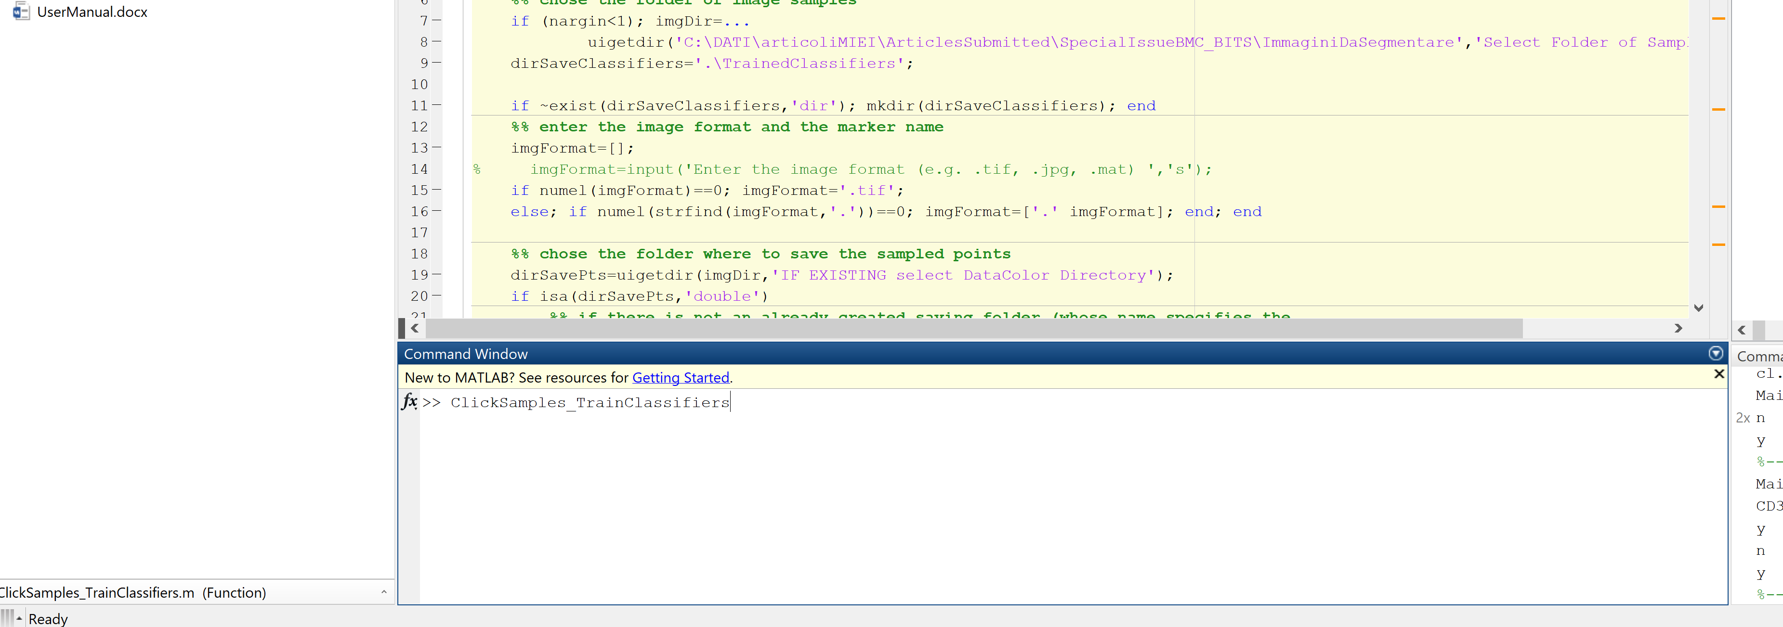

When the function starts, it opens a dialog box and asks you to locate and select the sampleImages folder in your PC (see below)

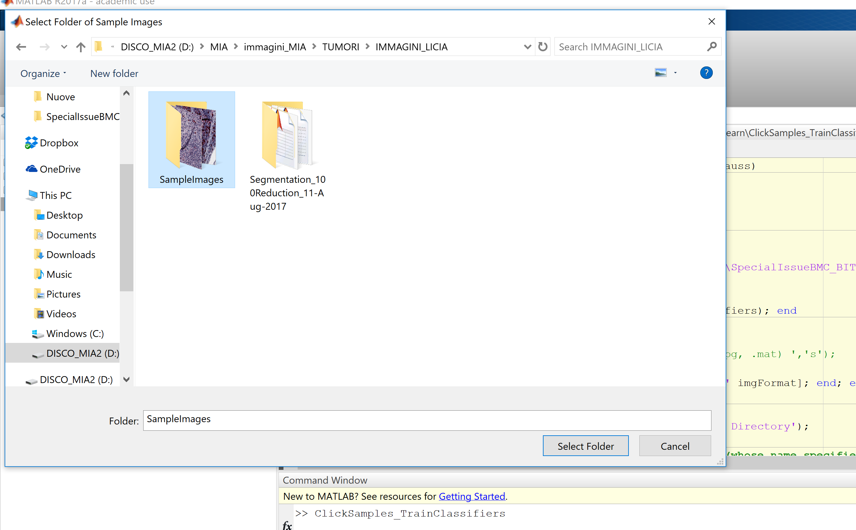

After this step MIAQuant_Learn parses the name of the first image in the folder and understand the name of the color that must be learnt (this is done by analyzing the color name written in the image name).

As an example, if the name of the first sub-image found in the folder is:

sample1_CD3_**BMCRV-R**_01.tif

MIAQuant_Learn understand that the user wants to use a basic color classifier named R and a stacked classifier recognizing a color named BMCR. In the following we will refer to the basic color name as baseColor, and to the specific color name as markerColor.

At first, MIAQuant_Learn checks whether a basic color classifier named basicColor already exists in folder TrainedClassifiers (as an example, if basicColor = R – which supposedly stands for red color – the basic color classifier might be existing if the user has already segmented markers with a reddish appearance; in this case he has created and used a basic color classifier named R to firstly screen all the red colors. Basic color classifiers can be recycled to segment any marker with reddish appearance). In this case, it asks if the user wants to train a novel basic color classifier. If the user prompts Y, a novel basic color classifier is trained. This happens also is the basic color classifier is not existing yet.

To select training pixel for the basic color classifier, the user is shown the RGB images and is asked to draw polygons including pixels whose color is that of the markers’ basic color (see below).

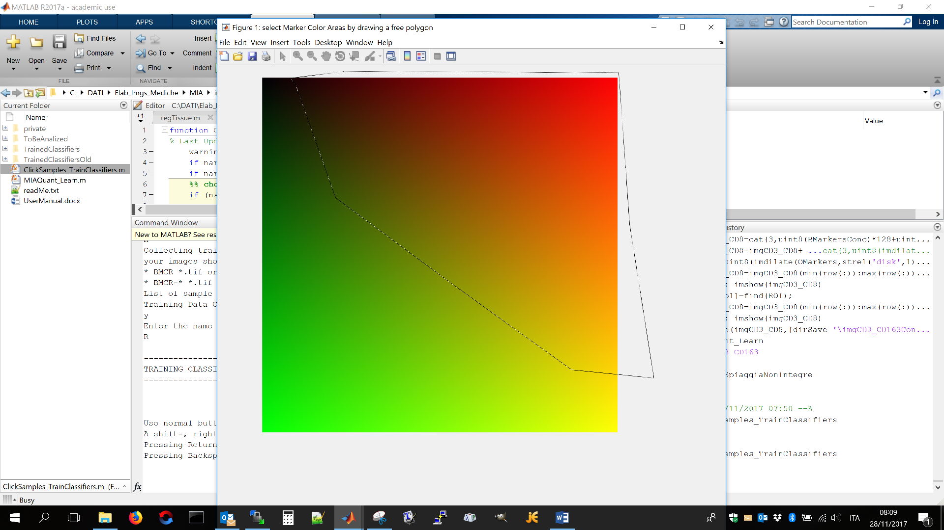

To end insertion of the closed line the user must double-click.

After selecting polygons on all the images (note that is an image does not contain pixels with the basic color to be learnt, the user can press enter to select no pixels), the basic color classifier is trained and saved in folder TrainedClassifiers.

After this step, the function checks if sampleImages contains a folder name “DataColor_markerColor” directory. This directory is created at the first run of the function “ClickSamples_TrainClassifier” and contains the points already clicked on the sample sub-images. At the first start, the directory is not existent and it is automatically created.

If folder “DataColor_markerColor” is already existing, MIAQuant_Learn output a message notifying that the directory already exists, meaning that the training points will be updated (see below)

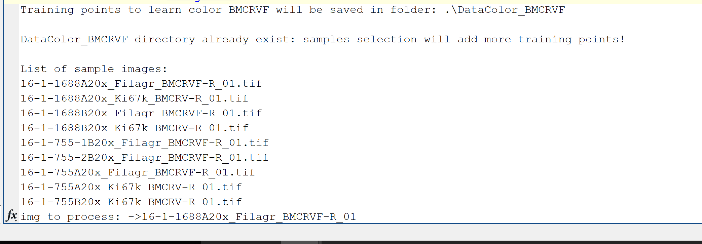

After this message, the list of sample images found in folder SampleImages is listed, and the function starts showing the name of the image to be clicked, and asking whether the user wants to click on it or skip it (see below)

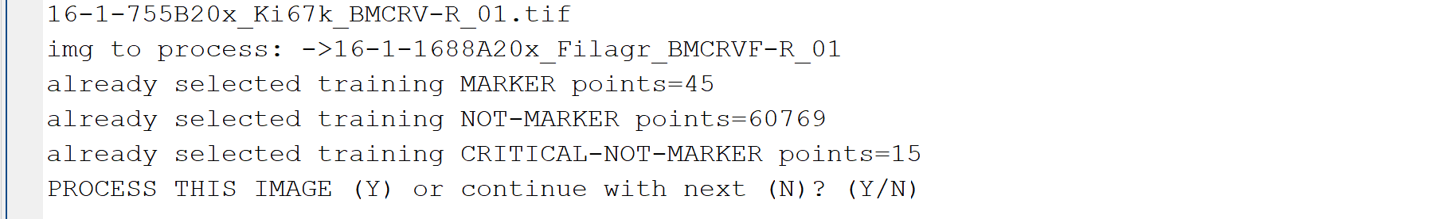

Inserting “N” will skip the image and ask about the next.

Inserting “Y” will open and show the image, asking to click on “center of areas where to select marker-pixels” (see below)

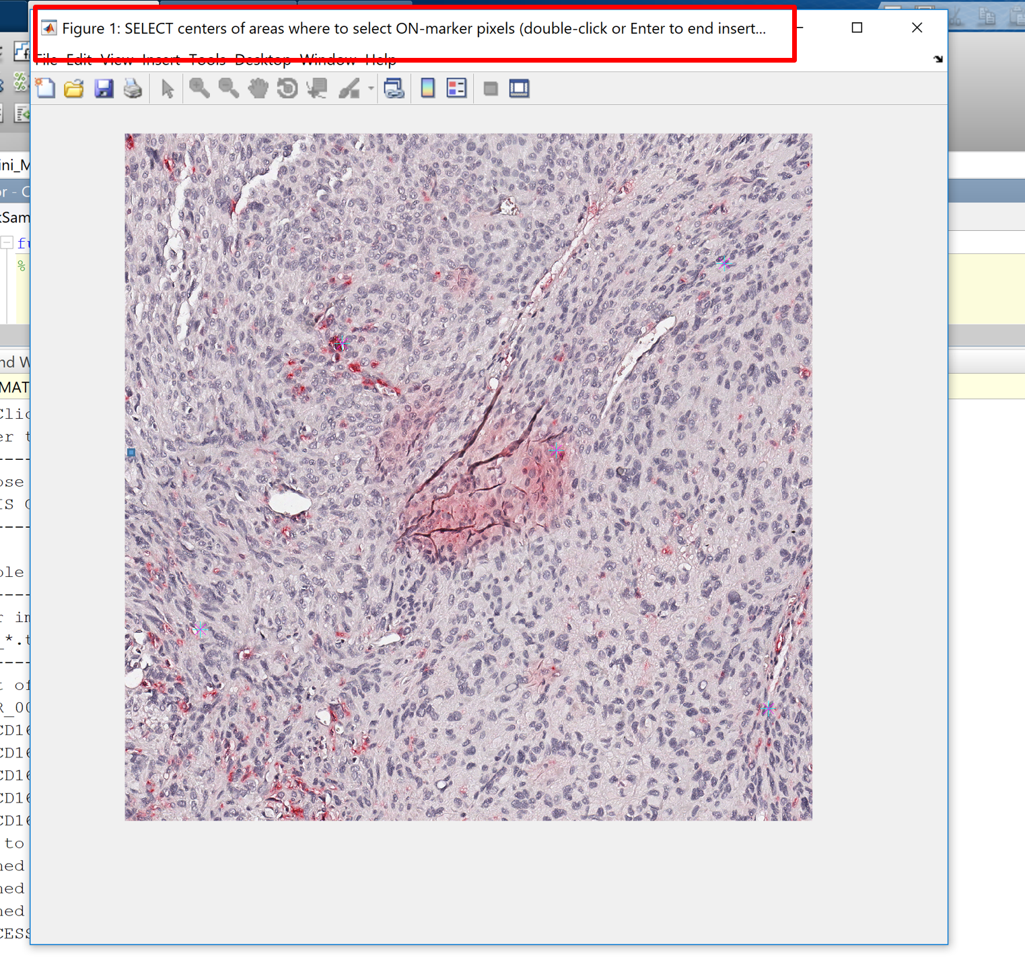

For each click, a sub-image containing the detail will be shown, and the user will be asked to select marker-pixels (see below). To end clicking on marker-pixels the user must press the “Enter” button on the keyboard.

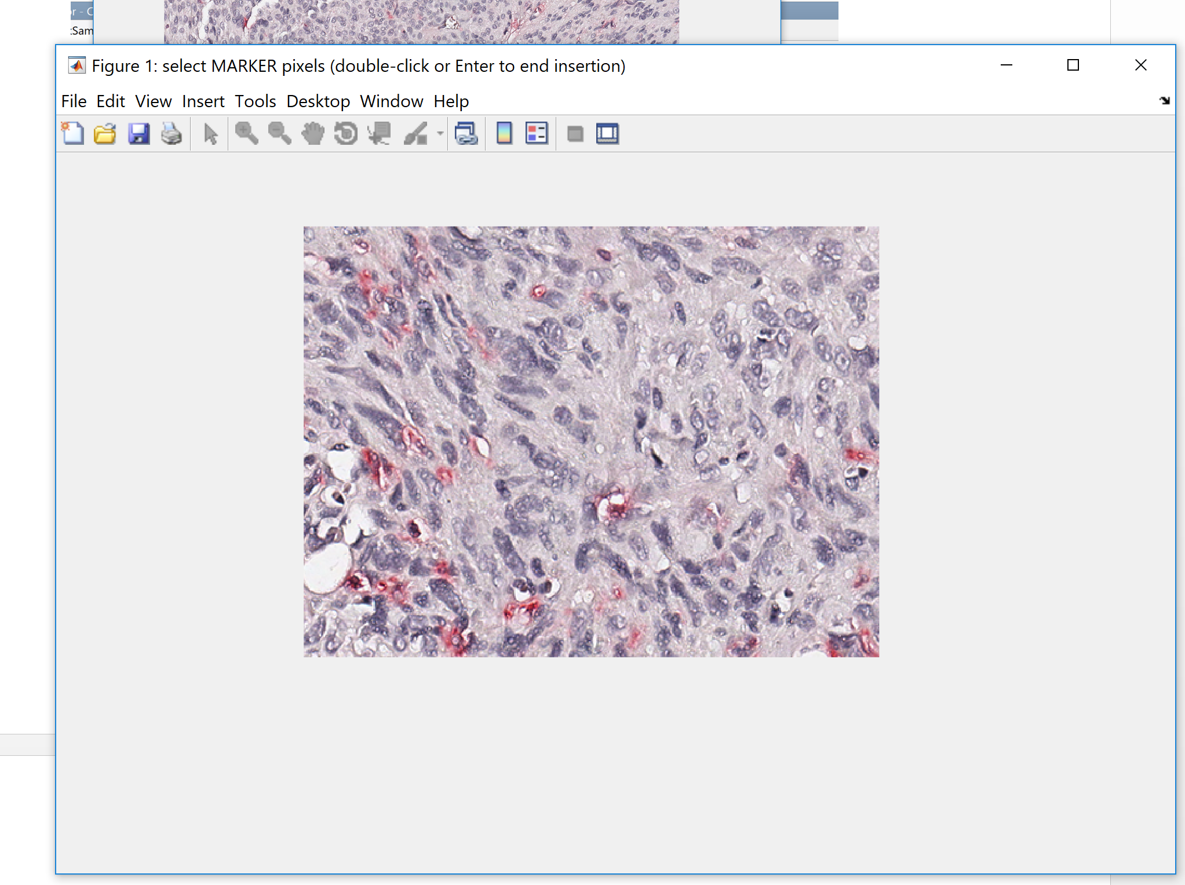

After selecting the marker pixels, a similar procedure is applied for selecting the not-marker points.

When clicking the not-marker pixels the user will note two differences:

* on each small image portion the user must firstly select the “obvious” not-marker pixels by drawing rectangular areas (if the user wants to click on not-markers he just needs to click one and the rectangular selection modality will switch to clicking selection modality);
* after finishing to click on not-marker pixles by pressing the “Enter” button the image portion is shown again and the user is asked to click on the critical not-marker pixels (pixels whose appearance is similar to marker-pixels, or pixels in folds, etc…)

When the user has finished clicking on each image, he can decide to proceed clicking on a novel sample image, or he might end clicking, to either train the classifiers with the collected training points, or interrupt clicking to start again later.

If the user presses Y continue clicking on the next image. Otherwise, he ends insertion. In this case, MIAQuant_Learn collects the training data (that is it codes the training points as 24 dimensional vectors).

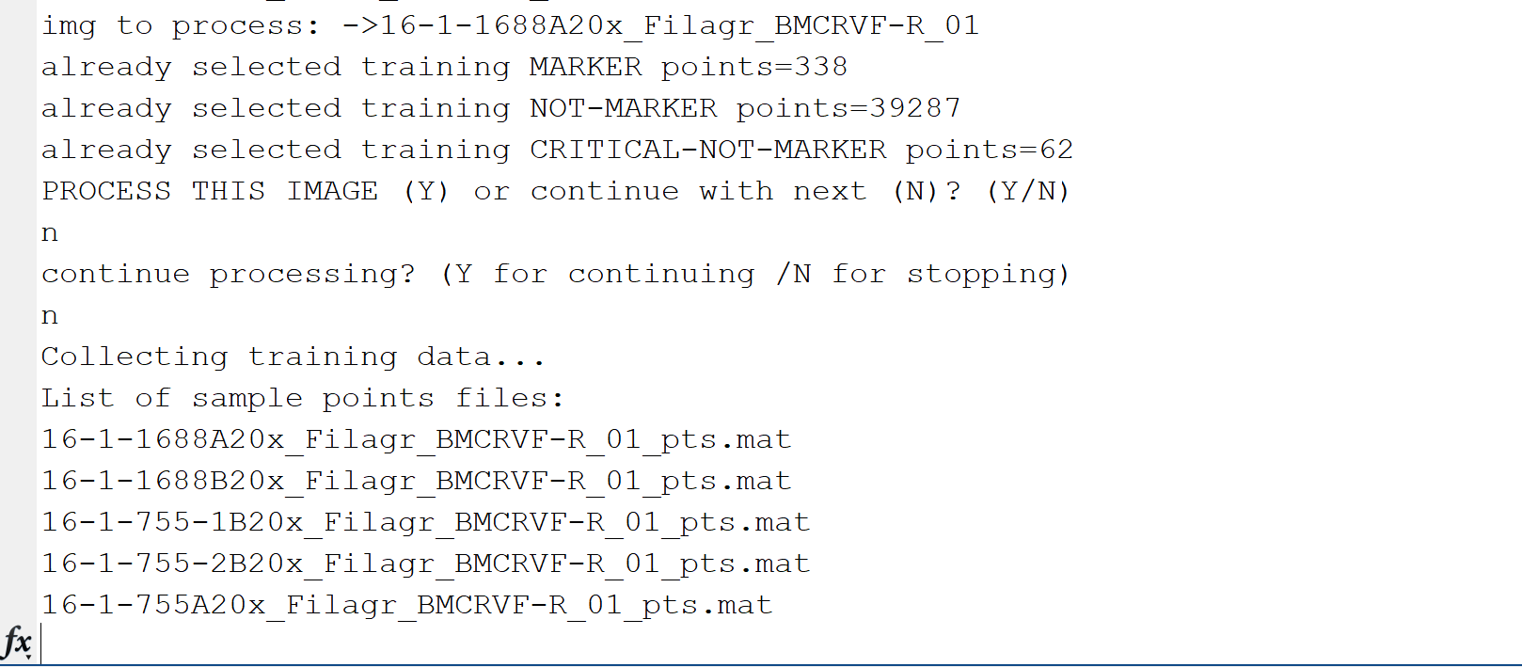

After this step it classifies training data with the basic color classifier, and outputs the achieved performance (see below).

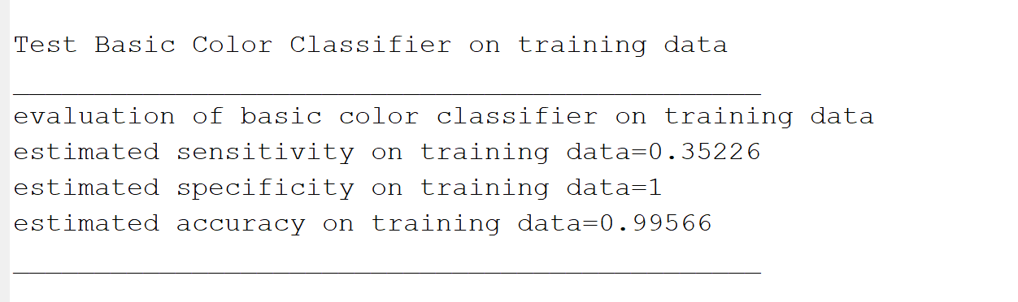

Note that this output allows the user to decide whether the basic color classifier must be retrained (as in this case!!) Indeed, the sensitivity is too low and would discard almost all the marker pixels. We recommend retraining the basic color classifier if sensitivity is lower than 0.99. Specificity is less important in this case (specificity values greater than 0.5 can be accepted, though they are generally much higher).

NOTE: If the user wants to retrain the basic color classifier he can finish the ongoing training and then restart the procedure. After training the basic color classifier he just stops to insert training points as soon as training point selection starts.

After classification with basic color classifier, the user is asked if the classifiers for marker color selection must be trained:

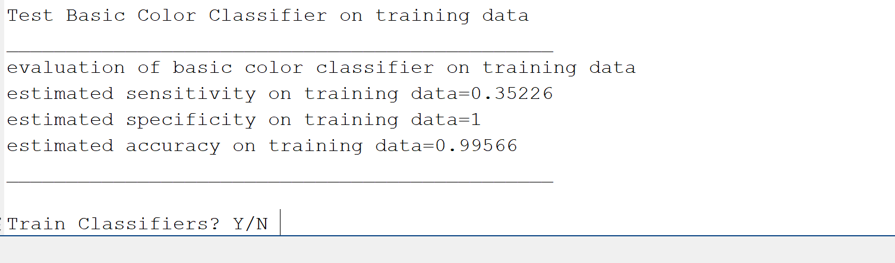

If the user answers “Y” training starts, otherwise the program is stopped (the user is expected to click later on some other images and then train the classifiers).

When the user wants to restart collecting training samples, he must launch again the function “ClickSamples_TrainClassifiers”, select the “SampleImages” folder, and then SELECT “DataColor_R”(if the color name chosen was “R”) WHEN THE SOFTWARE SHOWS A DIALOG BOX ASKING: 'IF EXISTING select DataColor Directory'.

IMPORTANT NOTE:

The user might not need to train the basic color classifier (though we suggest to do it). If no basic color classifier is trained, the image names will have the following format:

patCode_CD3_BMCR _01.tif,

patCode_CD3_BMCR_02.tif,

patCode_CD3_BMCR _03.tif

that is, the name of the color contains only the trained color name. We mark that the basic color classifier allow to discard most negative marker pixels and speed up computation. Moreover, basic color classifiers might be used whenever novel markers with the same basic color appearance must be segmented (as an example, we used a basic color classifier trained to recognize brown markers for completely different brownish markers appearances). After recognizing the basic color, the discrimination among the more specific color appearance is left to the stacked classifier machine, trained by the user clicks on the smple images.

## Run MIAQuant_Learn Software

To run the MIAQuant_Learn software, open the file “MIAQuant_Learn.m” (saved in the MIAQuant_Learn folder) with the latest MATLAB release.

This will open MATLAB platform and set folder MIAQuant_Learn as the current processing folder.

To run the code, in the command window write MIAQuant_Learn and press ENTER

Otherwise, press the Run button (the green triangle on the top of the MATLAB window - see image below).

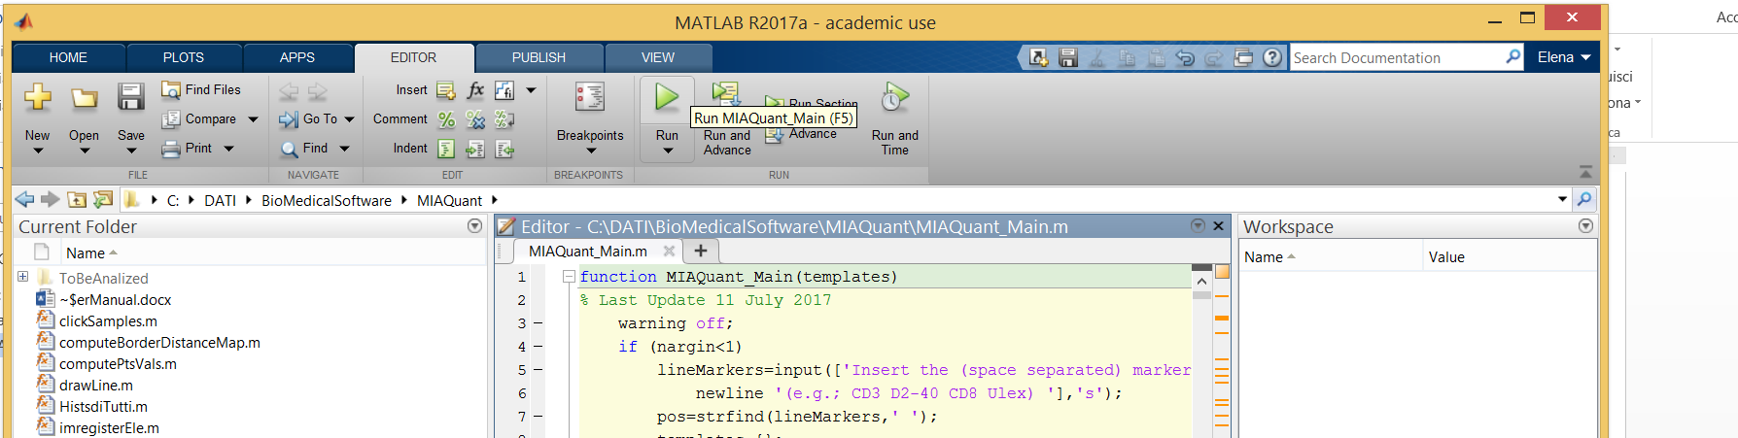



After pressing the running button, the program starts processing and requires the user to make some choices.

Precisely, a dialog box opens and asks the user to locate and select the folder containing the images to be processed.

After selecting the desired folder, the user is requested to

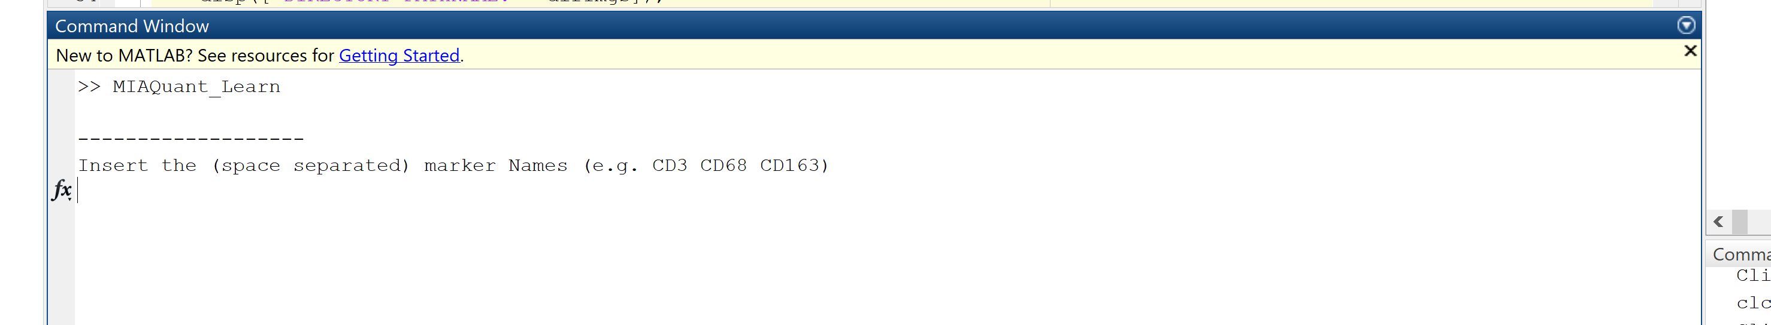

**The required list must report the name of markers to be analized**; this list must report the marker names as they are written in the names of images in the working folder. Referring to our examples, we insert the list: “CD3 CD68 CD163” (see below) and press enter.

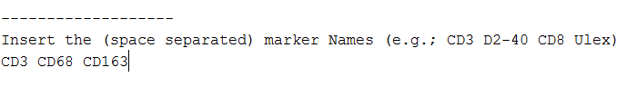

Note that the list of markers has a random order; the ordering is not important. **Be aware that each tissue sample in the folder must have one section image per marker**.

Next, the software asks:

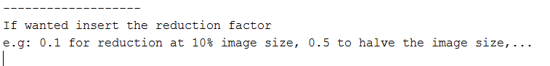The required **reduction factor** is needed to speed up computation when images are too big. This is the scaling factor, which allows to down-sample images at the inserted scale. It is expressed as a real valued number which must be bigger than zero and less or equal than 1 (0<factor<=1). A scaling factor equal to 0.2 (as the one in our example) down-samples the images so that their pixel-dimensions are the 20% of the original dimensions.

Next, the software asks to name the experiment. The name is important to save the results in a folder named with the experiment name. This helps running novel experiments by using already produced data (as an example, the user might firstly register images and compute co-existence measures in the whole tissue area; after this experiment, he might again need to evaluate co-existence in user selected areas, by analyzing registered images. In this case, using the same experiment name, registration will not be performed again, but already registered data will be used, thus saving much time).

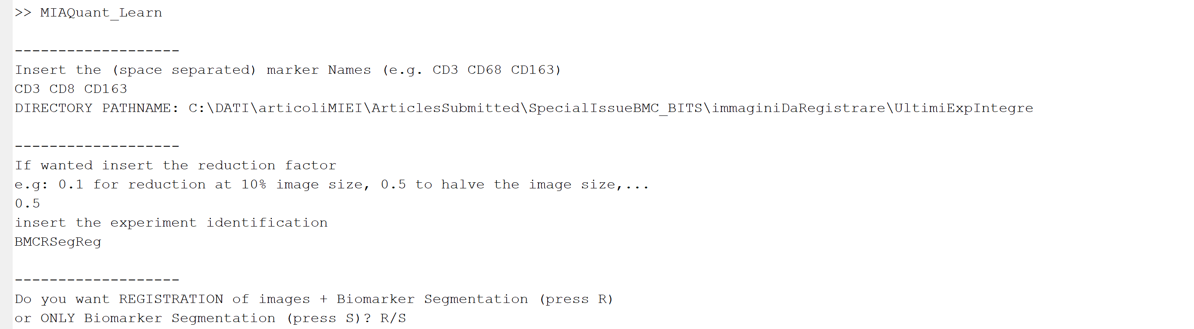

As shown in the image above the user is then requested if processing must be restricted to biomarker segmentation (followed by marker localization analysis), or registration before marker segmentation (and marker analysis) should be perfomed.

If the user prompts “S”, MIAQUant_Learn consecutively performs: biomarker segmentation, marker density estimation, computation of two mean-distance histograms. Precisely, the first histogram describes the distribution of the markers from the resection margins (this histogram is always computed). The second histogram describes the distribution of the markers from manually signed borders of structures of interest (this histogram is not computed if the folder InfoImg does not contain any image, with the same name of the processed one, containing a signed border in purple color). To compute the mean distance histograms the user might input a maximum distance: only markers within that distance from the resection border/border of the structure of interest will be considered while computing the histograms. If the user press enter without inserting any threshold, the maximum distance is computed as the maximum image size divided by 10. After this choices the user is requested if the segmented markers must be overlapped for visual comparison of marker co-existence and for computing co-existence measures (this is necessary if the user is working on serial sections).

If the user has serial section sets in his processing folder, he can press “Y”, otherwise the mandatory choice is “N”.

If the user wants marker co-existence analysis, he is also requested if the co-existence measures must be computed in specific areas. In this case, after having computed the overlapped image, it is shown and the user is requested to draw a closed line (to end insertion of the closed line the user must double-click).

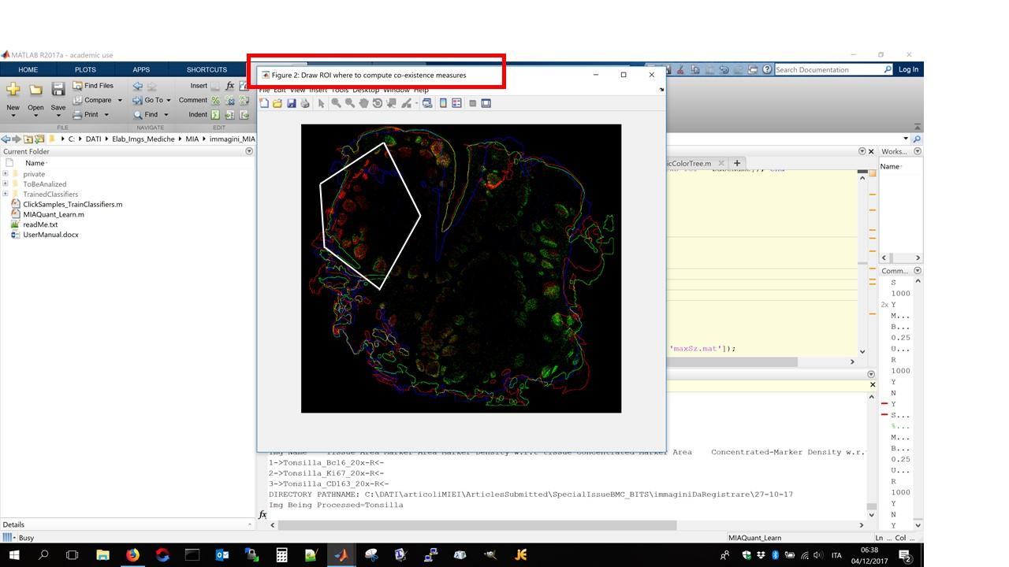

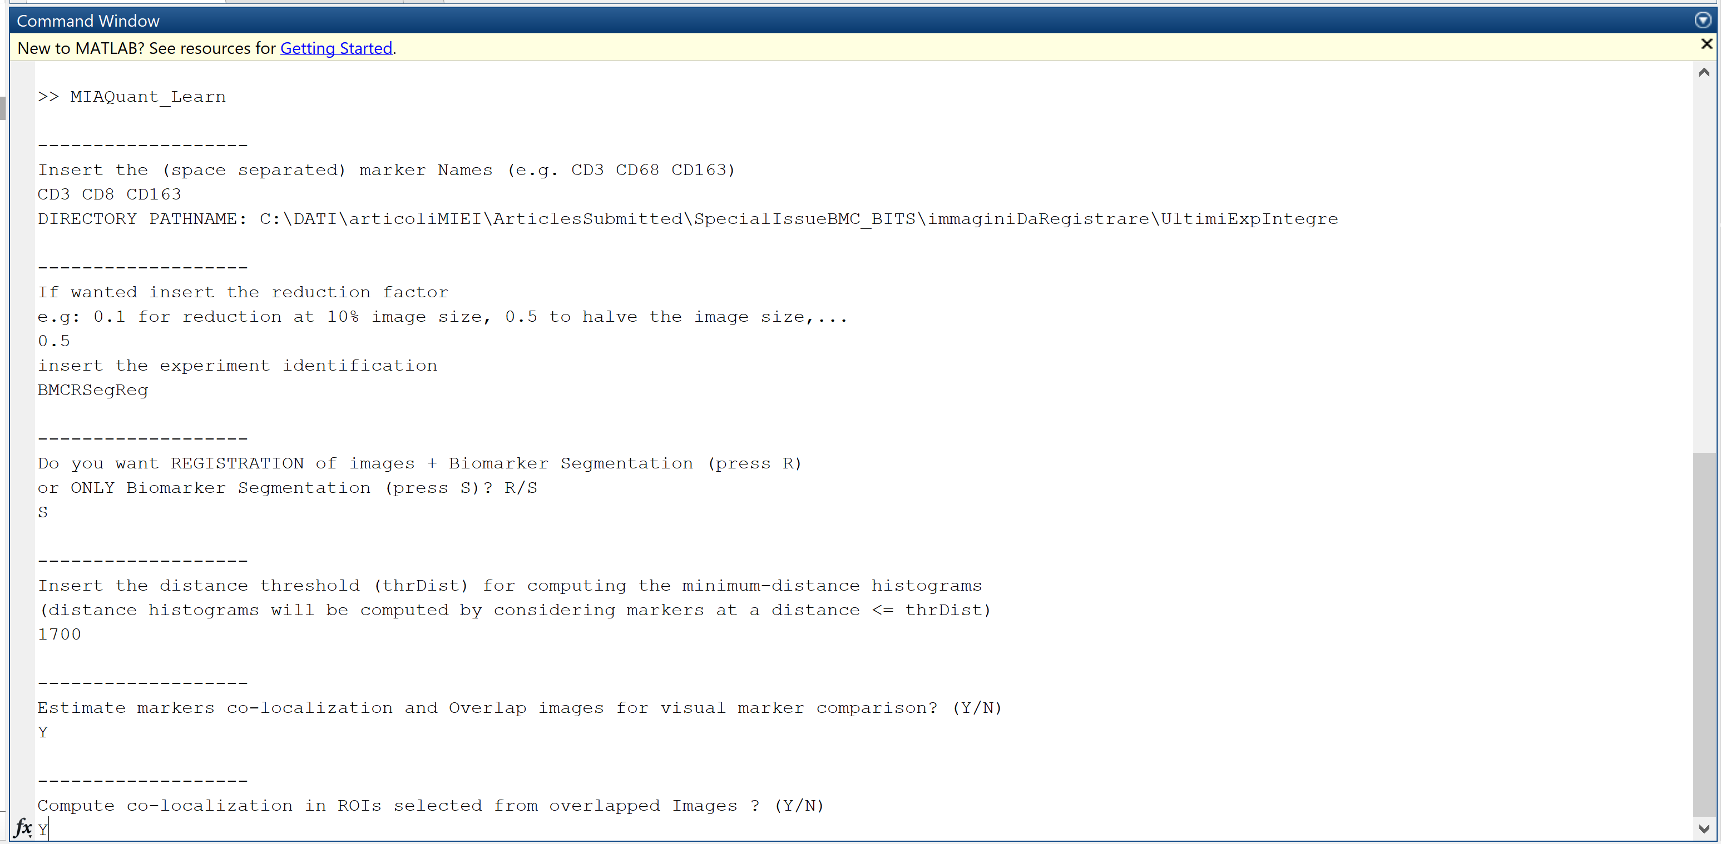

When “R” is pressed the user is requested to choose whether the registration steps must be:

* only multiscale-hierarchical registration based on tissue shapes;
* only hierarchical registration based on user-selected landmarks (this choice should be performed either when the tissue covers the entire image and has no borders, or when the user is interested in registering a specific region in the image);
* multiscale-hierarchical registration based on tissue shapes, followed by hierarchical registration based on user-selected landmarks (this obviously is expected to produce the best results).

The image below shows how to enter these preferences. In this example we have preferred to:

* down-sample images at their 20% pixel size,
* perform both automatic multiscale-hierarchical registration based on tissue shapes, and automatic hierarchical registration based on user selected landmarks, before segmentation and marker co-existence analysis.

After processing ends, the user finds saved results in folders created in the chosen working directory. The name of the folder reports the reduction factor and the date of execution.

The resulting folder is automatically created.

This folder contains some Matlab data stored during processing, plus “*_RegsF.jpg” images, which show, for each section, the segmented tissue area and the polygon whose vertexes are the manual Landmarks (if they are inserted by the user).

Furthermore, it contains the file “MarkerColocalization.txt” where all the co-existence measures are saved in case serial image sets have been processed.

Other results of the analysis can be found in two subfolders.

* Subfolder “Markers” contains all the segmented markers results. Precisely it contains images “*_BINmarker*.jpg” showing the binary result of segmented markers, images “_RGBmarker*.jpg” where the segmented markers are represented in their original color, and a file “MarkerDensityData.txt” containing the ‘tab’ separated marker density data (one line per image). Tab separated data can be imported from excel to allow a better visualization.
* Subfolder “Histograms” contains the computed mean-distance histograms and a ‘tab’ separated file (DistanceHistogramDifferences.txt) containing the histogram intersection measures.
* Subfolder “ResBeforeAfterReg” contains the overlapped results, before and after registration.

RUNNING EXPERIMENTS BY EXPLOITING ALREADY GENERATED DATA

Sometimes users might wish to run an experiments more times by changing its parameters (an experiment is defined by the processed image sets and by the reduction factor).

As an example, users may want:

* to perform all the three possible registrations (shape based registration, registration based on manually selected landmark, shape based registration followed by registration based on manually selected landmark),
* measure co-existence measures in the whole tissue area and then in ROIs,
* change the thresholds for computing the distance histograms.

In all these cases the user can run the experiment with the same settings (image dataset + reduction factor) and then mention the name of the experiment whose data must be recycled.

MIAQuant_Learn recognized whether data have been already produced and will not run old steps again, thus saving much computational time.

As an example, if the user wants to compute co-existence measures in ROIs on registered images, and the images have been already registered, he might simply issue the following commands.

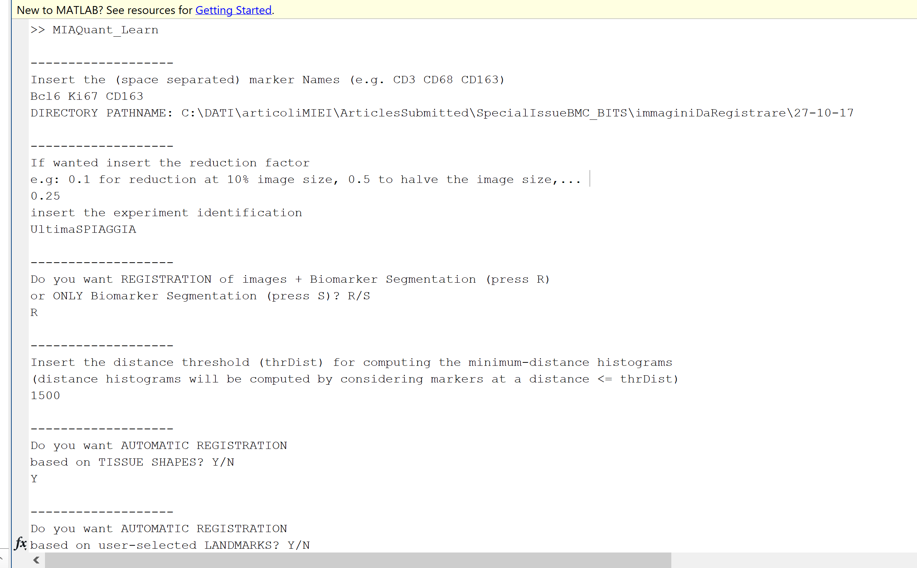

Basically, he needs to behave as if the experiment is to be run from scratch. However, MIAQuant_Learn detects that data is already existing and notifies the user of that (see below).

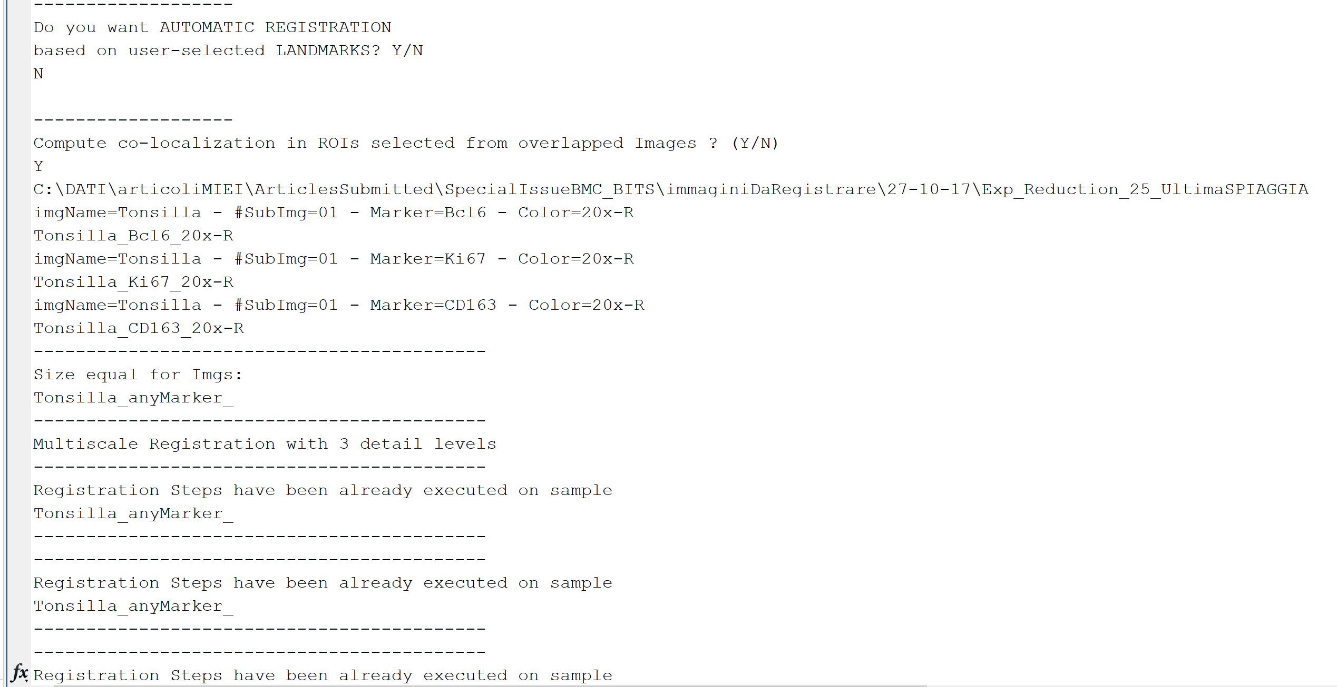

All the computation is faster and the user is soon shown the image where the ROI must be drawn (see below). Note that the novel co-existence measures will not overwrite the old ones, since MIAQuant_Learn appends all the computed information at the end of file “colocalization.txt”. Similarly, histograms computed with different thresholds are saved with a name reporting the threshold value.

